Concensus Maps
Alfresco : http://documents.horrycountyschools.net/share/
Login with your windows log in.
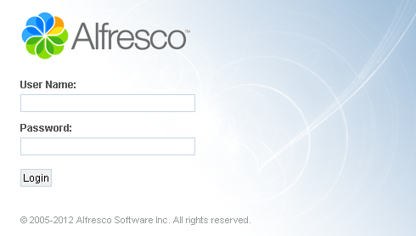
- Go to the button at the top labeled “sites”
- Click “Search for Sites”
- Type in the search window: HCS
- On the right side, across from the HCS Icon, click on “request to join”
- Go to “My Dashboard” by clicking on the button at the top
- Under My Sites, click on “HCS”
- Click on “Document Library”
- On the Left under Documents, click on the folder “Academics”
- Click on the folder “2013-2014 Curriculum Documents”
- Click on the correct folder, either “High School Math”
- At this point, you can bookmark the page if you want to
- Find your folder and check out the documents

